Internal server error - HTTP Error 500

The best and easy way to figure out the reason for “Internet server error 500” would be to check the error logs generated for your website. You can check the error logs by accesing cPanel > Error Log. Or else you could check the error logs by contacting your Web Hosting Service Provider.

While checking the error logs using cPanel you will see a detailed list of the last error messages generated by your website. It provides you with detailed information about each error occurred, with the date and time of the error, also information about the client receiving the error is included. It also provides information about which folder and file is causing or generating the error.
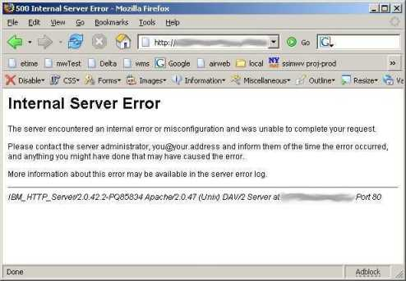
Below mentioned are examples of some errors causing an Internet server error 500 and steps to fix them :

- [2011-01-01 02:45:01]: error: directory is writable by others: (/home/user/public_html/)
The above error can be fixed by changing the permissions of the file or directory in consideration. You need to change the permissions by using the File Manager in cPanel, or by an FTP client. You need to enter the correct permissions, you can get the correct permissions by contacting you web hosting service provider.

- [2011-01-01 02:45:01]: error: file has no execute permission: (/home/user/public_html/)
While fixing this issue, you need to use your FTP client or the File Manager through your cPanel account and change the permissions. You can get the permissions from your Web Hosting Service Provider.

- [Sat Jan 01 02:45:01 2011][client 121.0.0.60] (13)Permission denied: /home/user/public_html unable to check htaccess file, ensure it is readable
The above error is caused because of incorrect permissions of the .htaccess file. Such an error message can also occur sue to incorrect permissions for the folder. You need to ensure that the permissions are correct. They can be obtained by contacting your web hosting service provider.

- [Sat Jan 01 02:45:01 2011] [client 121.0.0.86] Premature end of script headers: /home/user/public_html
Such error message could be occurred sue to several reasons:
The script requires more than the usual time to be processed and is being killed or terminated by the system.
This could also be because of an error within the programming code of the script in consideration. In such a case it should be revised by a professional web developer who will be able to assist you further.

